Jal Rekha
Application Architecture V 1.1
(Design & Process Flow Document)



M.P. STATE ELECTRONICS DEVELOPMENT CORPORATION LTD.
State IT Centre, 47-A, Arera Hills, Bhopal-462011 (M.P.)
www.mpsedc.mp.gov.in

Project Jal Rekha

Document APPLICATION DESIGN & PROCESS FLOW DOCUMENT

Document Name | Application Design Document
User Requirement Specification (URS) Document Version No. | 1.1
Effective Date

Author: | Reviewer: | Approver:
Dheeraj | Tapan Khandelwal | Dr. Rakesh Dubey
Signature | Signature | Signature
Electronics copies valid without signature

Version Number | Submission Date | Nature of Modification
Version 1.0 | 19/05/2025 | Base document
Version 1.1 | 30/09/2025 | Version Update document
Version 1.2 | 25/11/2025 | Process Flow O&M Billing, Bharosa & Material Testing Update document

Index
Contents
1. Introduction 8
2. Objective 8
Web Portal (.NET-Based Front End) 10
Android-Based Mobile Front End 10
REST Services with MVC Architecture 11
Business Rule Engine (BRE) 11
Database Layer 11
Integration Services 11
Client Side 14
Architecture Principle 14
Service Layer 15
Major API Services Integrated 15
Server Side 15
1. Presentation Layer (Controller Layer) 15
2. Application Layer 15
3. Domain Layer 16
4. Data Layer 16
3. Process Flow 17
4. Business Rule Engine 26
1. User Roles and Privileges 26
2. Asset Mapping Rules 26
3. RFI (Request for Inspection) Workflow Rules 27
4. Data Collection and Validation Rules 27
5. Work Progress Monitoring Rules 27
6. Integration and Data Synchronization Rules 28
7. Security and Authorization Rules 28
8. Reporting and Dashboard Rules 28
9. Notifications and Alerts 28
10. Caching and Performance Rules 29
4.1. Rule Processor 30
1. Purpose of the Rule Processor 30
2. Rule Execution Flow 31
Step 1 – Request Triggered 31
Step 2 – Rule Invocation 31
Step 3 – Rule Validation 31
Step 4 – Decision Making 31
3. Types of Rules Managed by the Rule Processor 31
4. Key Features of the Rule Processor 32
5. Rule Processor Integration in Jal Rekha 32
6. Example Scenarios 32
Scenario 1 – RFI Approval Workflow 32
Scenario 2 – Asset Mapping Validation 32
7. Benefits of the Rule Processor 33
5. Database Components 34
6. Action Template 35
7. Code Structure 36
8. DATA DESIGN 37
8.1. Database Architecture Diagram 37
9. NETWORK DESIGN 38
9.1. Network Architecture Diagram 38
1. Client Layer 38
2. DMZ Layer (Demilitarized Zone) 39
Key Components in DMZ: 39
3. MZ Layer (Main Zone / Data Layer) 39
Key Components: 39
4. Security Features 40
5. High Availability & Replication 40

Introduction

Jal Rekha is a comprehensive GIS-based solution developed for MP Jal Nigam Maryadit to enable efficient planning, monitoring, and management of water supply schemes across Madhya Pradesh. The system consists of a web portal and a mobile application designed to facilitate seamless data collection, asset mapping, progress tracking, and performance monitoring of various water supply projects. By integrating advanced geospatial technologies, Jal Rekha ensures accurate visualization and real-time status reporting of ongoing works.
The primary objective of Jal Rekha is to streamline departmental operations by enabling effective task assignment, work progress monitoring, and data-driven decision-making. The platform empowers field engineers, contractors, and department officials to collaborate effectively through features like asset mapping, RFI management, inspections, and reporting dashboards. This Functional Requirements Specification (FRS) document defines the detailed requirements, functionalities, and workflows necessary for the successful implementation and operation of the Jal Rekha system.

Objective

The system aims to streamline the entire process of data collection, inspection, verification, billing, grievance redressal, and reporting, ensuring transparency and accuracy in managing various water infrastructure components.

  - Architecture Design and Components

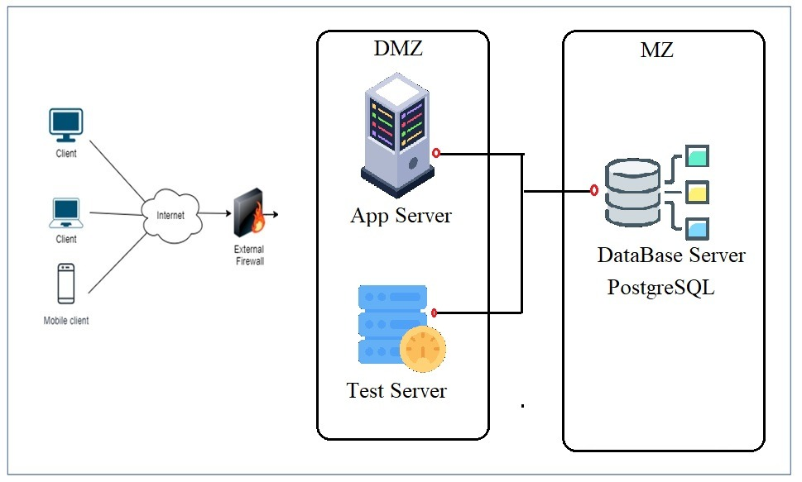

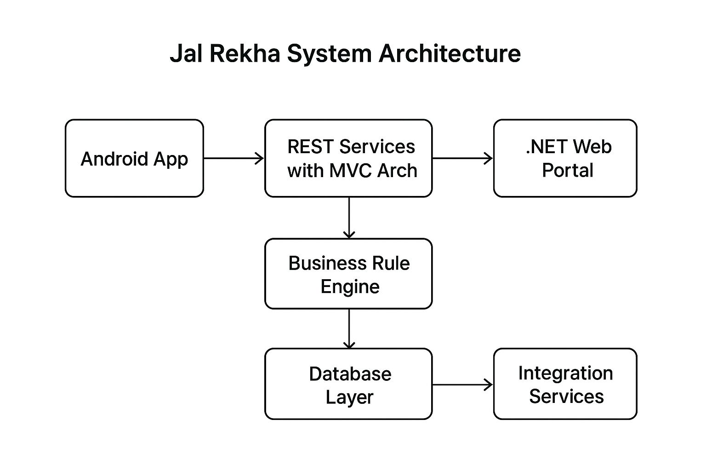

Web Portal (.NET-Based Front End)
- The Jal Rekha Web Portal is developed on the .NET framework, designed for department officials, administrators, and higher authorities.
- It enables planning, monitoring, approvals, task assignments, and progress tracking of water supply schemes.
- The web portal interacts seamlessly with the same RESTful services used by the mobile application, ensuring real-time synchronization of data across platforms.
- Authorized users can manage user roles, approve RFIs, generate reports, and access GIS-based dashboards through the portal.

Android-Based Mobile Front End
- The Jal Rekha Mobile Application is developed on Android to enable field-level data collection, asset mapping, inspection reporting, RFI submissions, and progress monitoring.
- The mobile application communicates with the RESTful services built using the MVC (Model-View-Controller) architecture.
- Field engineers, contractors, and other on-site users primarily interact with Jal Rekha through the mobile app.
- Future front-end applications, such as an iOS app, can also be integrated within the same architecture, but user onboarding and authentication will primarily be managed via the Android application.

REST Services with MVC Architecture
- Jal Rekha follows a decoupled RESTful architecture, allowing mobile apps, the web portal, and other integrated systems to interact independently.
- The MVC structure ensures modular development and simplifies testing, maintenance, and future scalability.
- Both the Android app and the .NET web portal communicate with these REST services after successful authentication.
- Token-based authorization is implemented at the application level to secure data exchange and user operations.

Business Rule Engine (BRE)
- The Business Rule Engine governs all workflows, validations, and approval processes within Jal Rekha.
- All rules, roles, and privileges are defined at the database level, ensuring centralized control over system operations.
- User permissions are dynamically assigned based on their roles, enabling controlled access to modules like asset mapping, inspections, approvals, reporting, and dashboards.

Database Layer
- The database layer securely manages all datasets required across the Jal Rekha platform, including user profiles, asset data, inspection details, RFI status, and scheme information.
- Data is stored using Object Relational Mapping (ORM) techniques for seamless integration between applications and the database.
- The database is synchronized between the primary server and integrated application services to ensure real-time data availability.
- Role-based access controls and privileges are also maintained at the database level to secure user operations.

Integration Services
- Jal Rekha supports integration with third-party services for better user experience and operational efficiency.
- Email services are integrated for user registration, password resets, profile updates, and notification alerts.
- Planned future integrations include:
  - SMS gateways for status updates and reminders
  - GIS-based services for advanced mapping and visualization
  - Analytics tools for insights, reporting, and performance monitoring

  - Data Flow Diagram
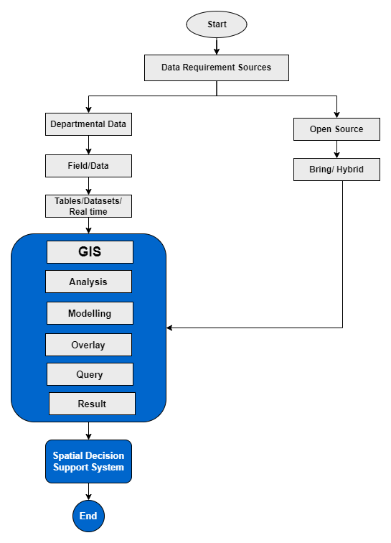

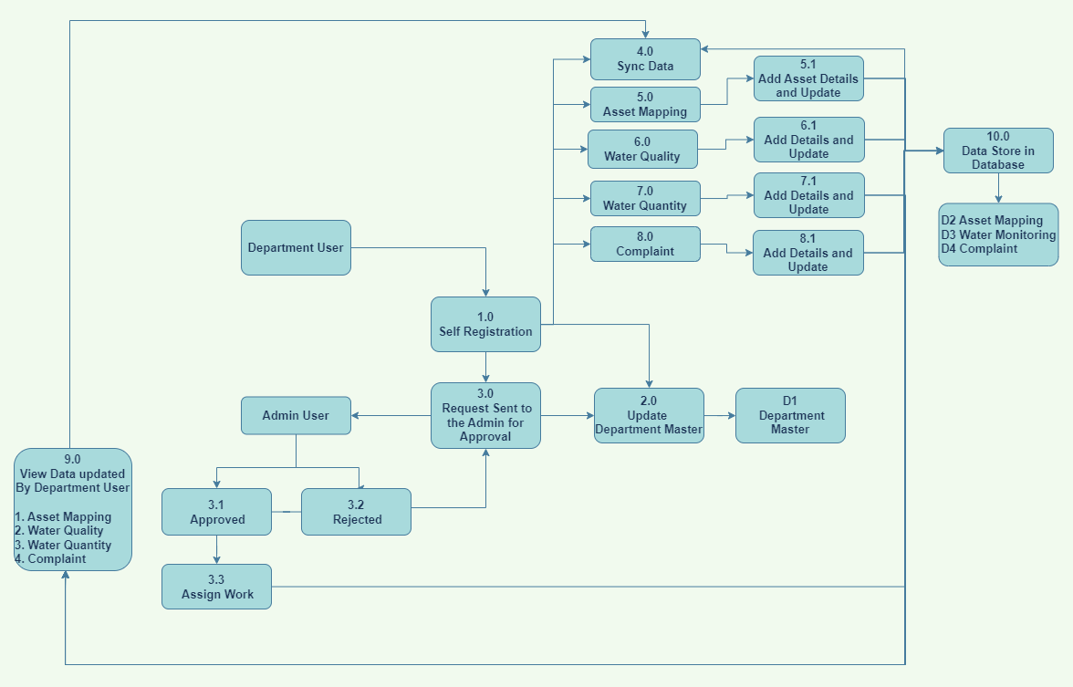

Client Side
- The Jal Rekha Mobile Application is developed using Android for User Interface (UI) development to facilitate asset mapping, RFIs, inspections, approvals, and progress monitoring.
- The Jal Rekha Web Portal is developed on .NET Framework and serves as the primary platform for department officials, administrators, and higher authorities to manage workflows, dashboards, and reporting.
- Both Android and .NET front ends communicate with RESTful APIs through a secure channel.

Architecture Principle
- Each component in the mobile application depends only on the layer directly below it, ensuring loose coupling and maintainability.
  - Activities and Fragments → depend only on the ViewModel.
  - ViewModel → depends on the Repository layer.
  - Repository Layer → connects to both persistent data models (local database) and remote backend services.
- The Repository acts as a single source of truth and manages data synchronization between the local database and remote API services.

Service Layer
- The Service Layer acts as the bridge between the client side and the server side, handling API communications.
- Each Android service sends and receives multiple API requests such as:
  - User login & authentication
  - Data submission & updates
  - Asset details & RFI tracking
  - Report generation & progress monitoring
- Services ensure real-time data exchange between field users, the server, and the Jal Rekha database.

Major API Services Integrated
- Geoportal Service
- PM Gatishakti
- MP Bhulekh
- Jal Samgra

Server Side
The server-side architecture of Jal Rekha is based on .NET MVC principles and consists of Presentation Layer, Application Layer, Domain Layer, and Data Layer.

1. Presentation Layer (Controller Layer)
- The Controller handles requests from the front end (Android & Web Portal).
- It sends commands or queries to the Application Layer.
- Controllers validate inputs, initiate business processes, and return structured responses to clients.

2. Application Layer
- Manages the application services and orchestrates workflows.
- Responsible for executing service requests using:
  - Domain Entities (business models)
  - Repositories (data access and persistence)
  - Integration Agents (for external services)
- Implements all business rules, validations, and authorization checks.

3. Domain Layer
- Domain Entities are model classes representing database tables and mapping data between the database and the API.
- RepositoryBase (abstract class) and IRepositoryBase (interface) are implemented to provide a generic repository pattern:
  - Reusable CRUD operations for all entities.
  - Entity-specific repositories inherit from the RepositoryBase.
  - Allows creating custom interfaces for entity-specific operations while keeping common logic centralized.

4. Data Layer
- The Data Layer manages:
  - Repositories → provide data access through a generic repository pattern.
  - Mapping → binds database models to table fields and handles request/response translation.
  - Database Context → maintains database connections and session handling.
  - Service Agents → manage third-party integration and external data exchange.

Process Flow

    - Asset Mapping:
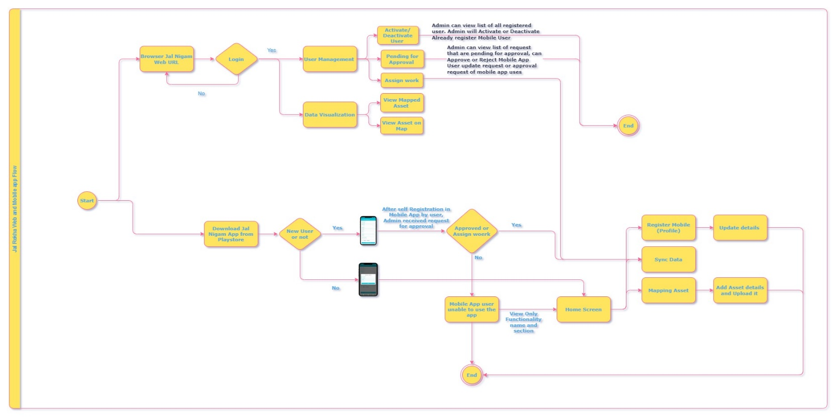

    - Asset Mapping:
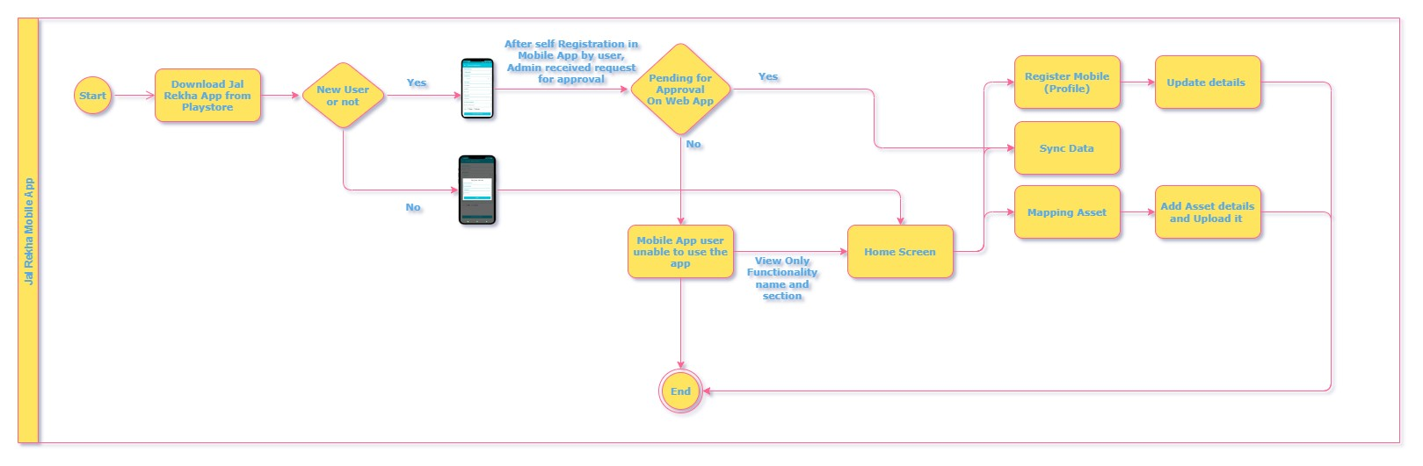

    - Dhara:
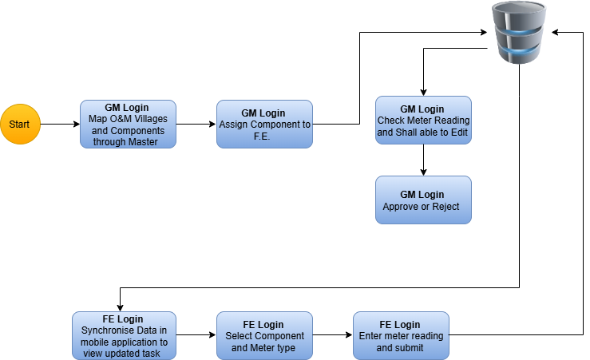

    - Nirmal :
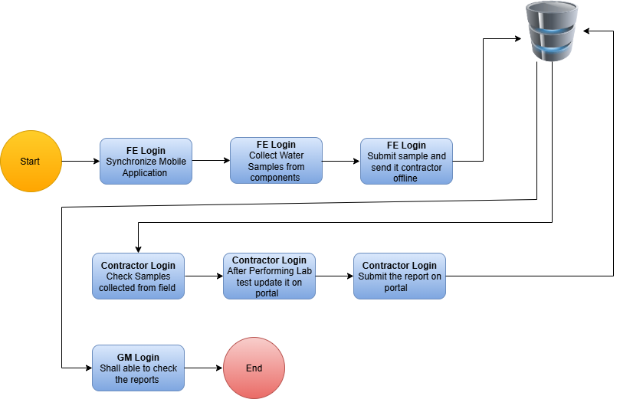

    - Sahbhagita:
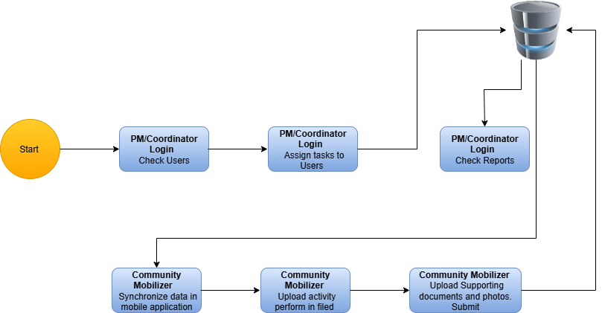
    - Sopan
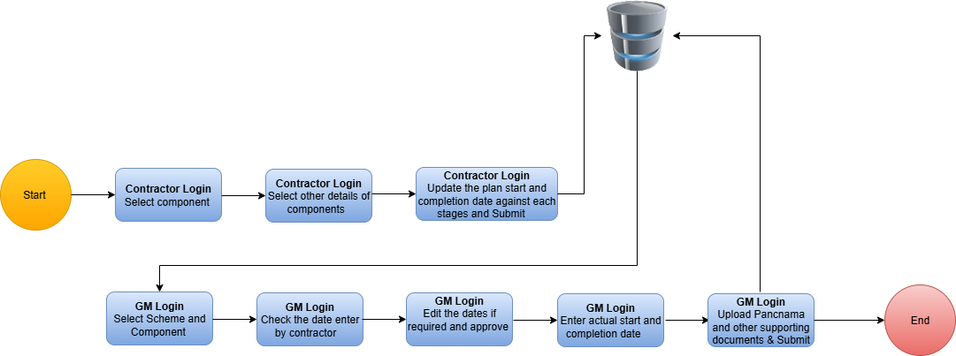

    - User Management

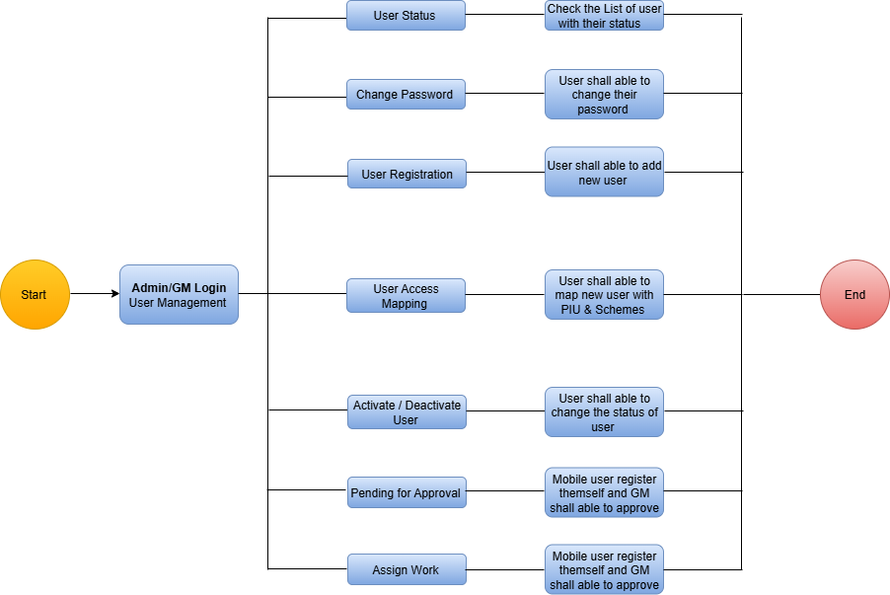

    - FHTC HSC – Household Tap Connection

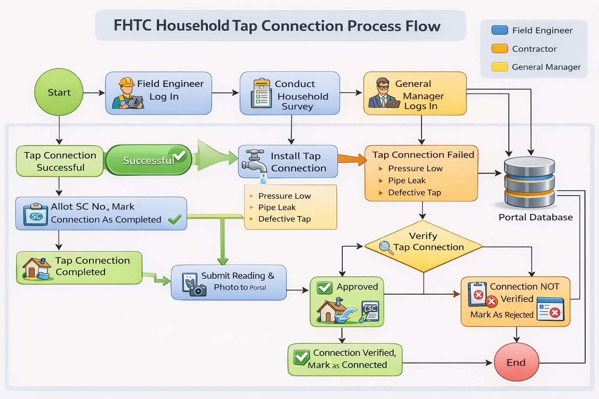

    - O&M Billing

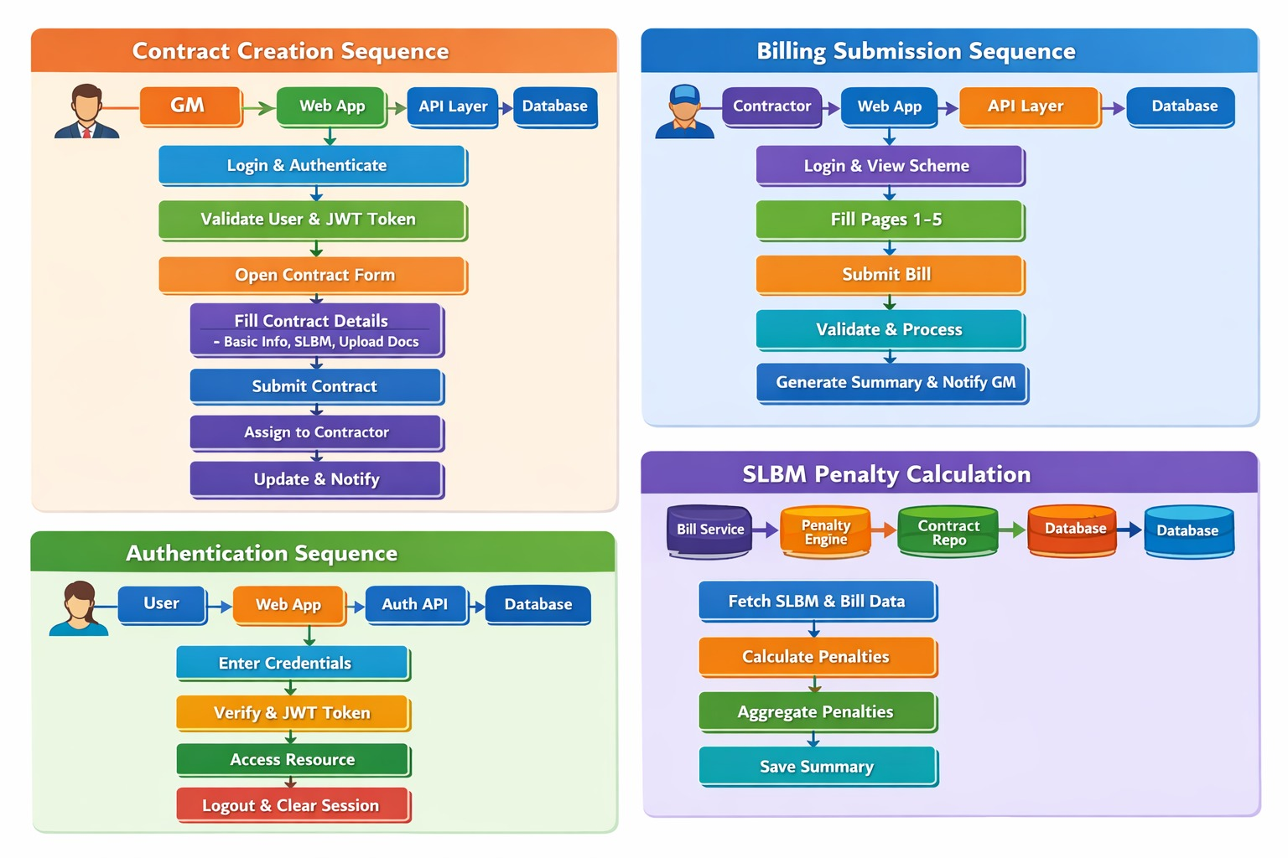
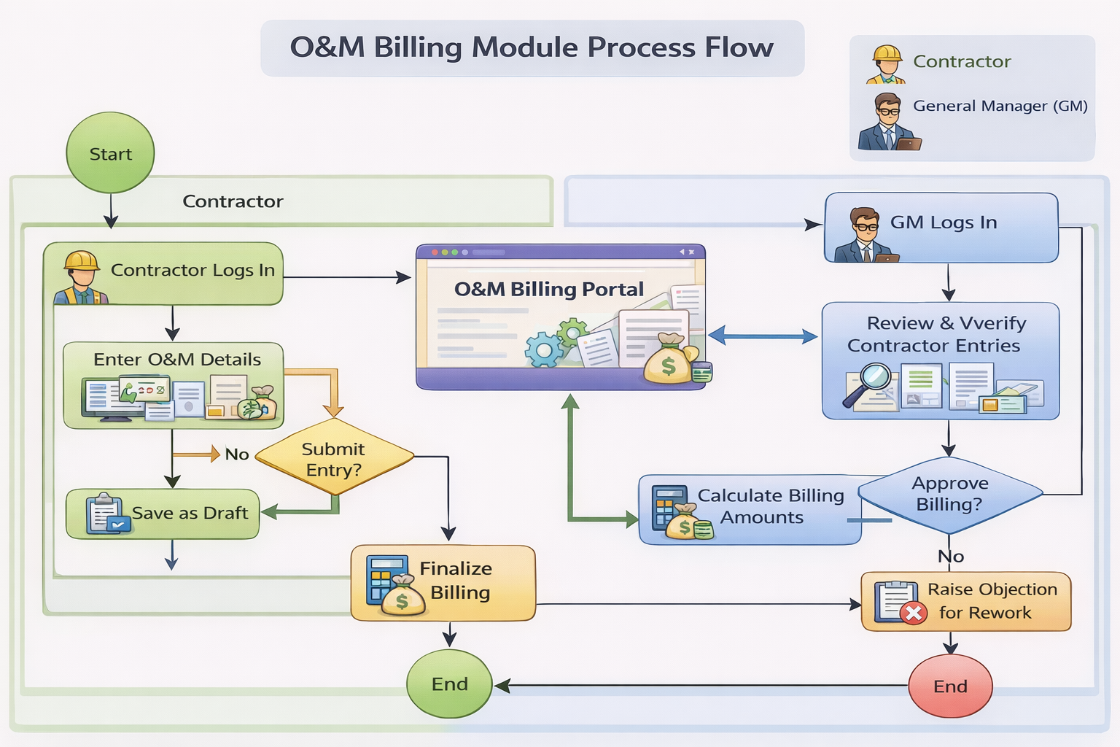
    - Bharosa Factory Testing
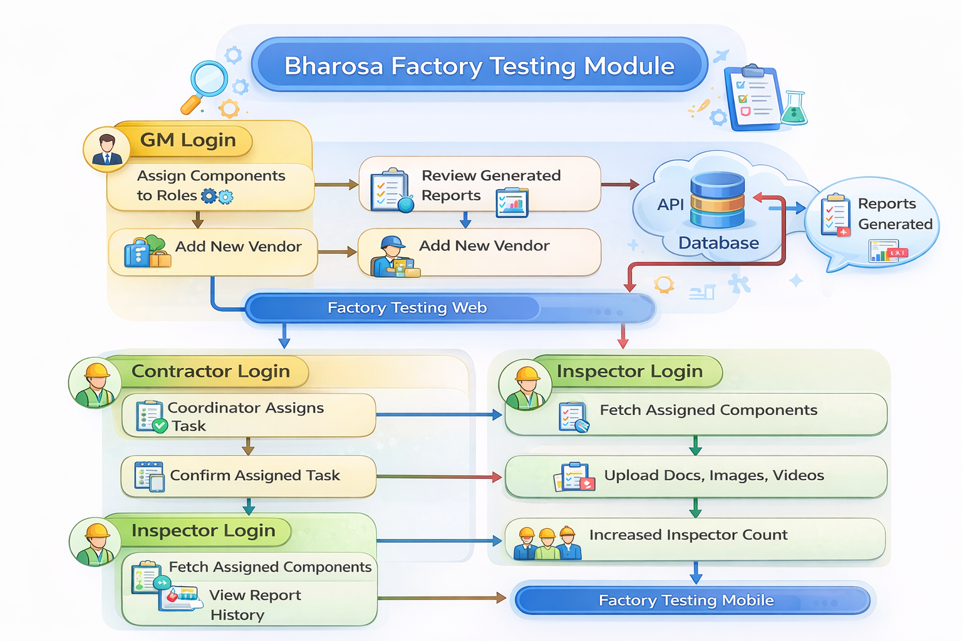

    - Material Testing

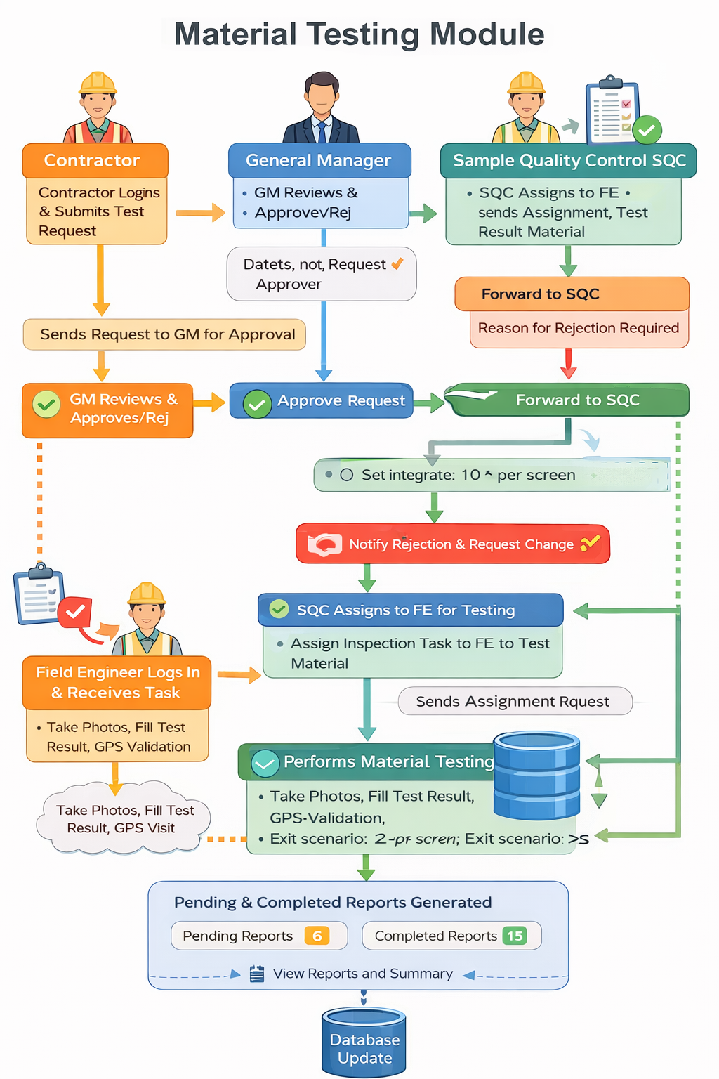

Business Rule Engine

The Business Rules define the workflows, validations, roles, privileges, and data handling policies for the Jal Rekha system. These rules ensure data integrity, controlled access, and smooth coordination between field engineers, contractors, department officials, and administrators.

1. User Roles and Privileges
The system follows role-based access control (RBAC) to manage permissions:
Role | Responsibilities | Access Level
Admin | User creation, role assignment, monitoring, and system configuration | Full access
Department User | Approval of RFIs, assigning inspections, monitoring progress | High-level access
Field Engineer (FE) | Asset mapping, RFI inspections, uploading photos, videos, and coordinates | Module-level access
Contractor | Submit RFIs, update work details, upload documents | Restricted access
Viewer | Access to dashboards, reports, and progress tracking | Read-only access
Business Rule:
- Each user must be authenticated using a unique ID and secure token before accessing the system.
- Users can only access modules and data assigned to their role.

2. Asset Mapping Rules
- Assets include pipelines, water treatment plants, OHTs, intake wells, and village-level connections.
- Field Engineers can add, update, and verify asset data through the Android app.
- Each asset must have mandatory attributes:
  - Asset Type
  - Asset ID
  - GPS Coordinates
  - Capacity/Dimensions
  - Photographic Evidence
- Business Rule:
  - No asset record can be saved without latitude-longitude coordinates and geo-tagged photographs.
  - Duplicate asset entries are not allowed.

3. RFI (Request for Inspection) Workflow Rules
Workflow:
Contractor → General Manager (GM) → Team Lead (TL: SQC/TPIA/Both) → Field Engineer (FE) → Department Approval
Business Rules:
- Contractors must raise RFIs before completing a major activity like pipeline laying, OHT construction, or WTP installation.
- The system automatically assigns inspection tasks to the TL or FE based on the location and work package.
- Inspection reports must include:
  - Photos/videos of work
  - Inspection status (Approved/Rejected)
  - Remarks for non-compliance
- No payment to the contractor will be processed unless the RFI is approved by the department.

4. Data Collection and Validation Rules
- Field Engineers must collect and upload:
  - Pipeline details (size, material, length)
  - Component details (WTP, OHT, intake wells)
  - Photos, videos, and geo-coordinates
- Business Rules:
  - The system validates mandatory fields before allowing data submission.
  - Uploaded photographs must be geo-tagged to ensure on-site verification.
  - In case of missing or invalid data, the system will flag the entry for review.

5. Work Progress Monitoring Rules
- Work progress will be tracked scheme-wise, contract-wise, and location-wise.
- Contractors must regularly update progress through the app.
- Department users can monitor work using the dashboard and GIS map integration.
- Business Rule:
  - Any scheme without updated progress for 15 consecutive days will be auto-flagged as “Delayed” in the dashboard.

6. Integration and Data Synchronization Rules
- Jal Rekha integrates with:
  - Geoportal Services – for real-time mapping
  - MP Nagar Palika Database – for scheme and contractor information
- Business Rules:
  - Data synchronization between Android app, web portal, and central database must happen in real-time.
  - In offline mode, the mobile app stores data locally and pushes updates automatically when the network is restored.

7. Security and Authorization Rules
- The system uses token-based authentication for all API calls.
- User credentials are encrypted before storage and transmission.
- Unauthorized access attempts are logged and reported automatically.
- Business Rule:
  - Each API request must include a valid authorization token.
  - Session timeout will occur after 15 minutes of inactivity.

8. Reporting and Dashboard Rules
- Reports are generated for:
  - Scheme-wise status
  - Asset mapping coverage
  - Inspection progress
  - RFI approvals and rejections
- Business Rule:
  - Only department users and administrators can generate consolidated reports.
  - Contractors can access their own reports but not other contractors’ data.

9. Notifications and Alerts
- Email and SMS notifications are sent for:
  - RFI approvals/rejections
  - Pending inspections
  - Work delays
  - New user registration and profile updates
- Business Rule:
  - Notifications are triggered automatically based on predefined workflows.
  - Users can configure notification preferences in their profile.

10. Caching and Performance Rules
- Frequently accessed datasets like master data, asset types, and user roles are cached for better performance.
- Business Rule:
  - Cache refresh happens every 24 hours or on-demand when updates are made.
  - If cached data conflicts with the database, the database version always overrides.

Rule Processor

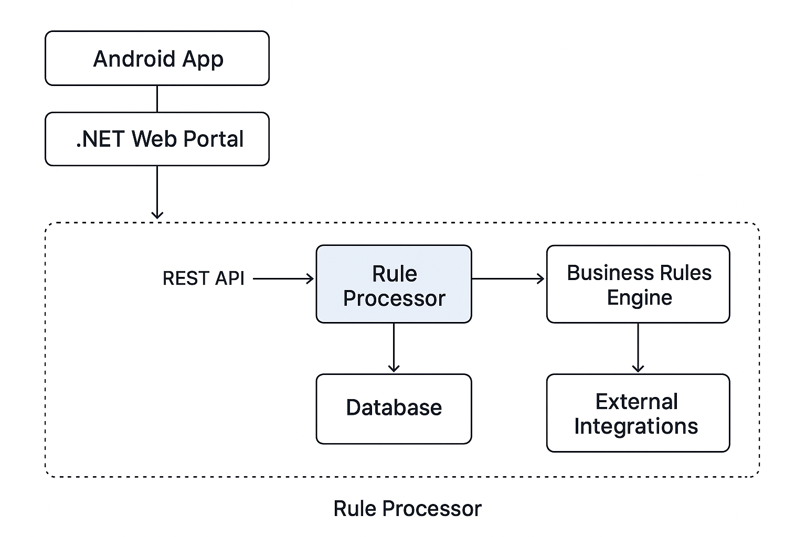
The Rule Processor in Jal Rekha is the core component responsible for executing, validating, and managing business rules defined within the system.
It ensures that every workflow, inspection, asset update, and approval process follows predefined policies, user roles, and access privileges.

1. Purpose of the Rule Processor
- To ensure consistency in workflows and validations.
- To automate decision-making based on predefined rules.
- To control access permissions based on user roles and privileges.
- To ensure data accuracy and prevent unauthorized updates.

2. Rule Execution Flow
The Rule Processor works as a middleware layer between the Application Layer and Database Layer.
When any request is made (e.g., asset update, RFI approval, progress submission), the following flow occurs:

Step 1 – Request Triggered
- A user initiates an action from either:
  - Android App
  - .NET Web Portal

Step 2 – Rule Invocation
- The Rule Processor fetches the relevant business rules based on:
  - Module (Asset Mapping, RFI, Inspection, Progress Monitoring, etc.)
  - User Role (Contractor, Field Engineer, Department User, Admin)
  - Workflow Stage (Pending, In-Progress, Approved, Rejected)

Step 3 – Rule Validation
- Validates:
  - User authentication & authorization
  - Mandatory field completion
  - Asset duplication checks
  - Geo-coordinates & photo validations
  - Approval hierarchy checks

Step 4 – Decision Making
- If the request meets all defined rules, the processor allows the operation and passes it to the database layer.
- If the request fails any validation, it is rejected with an appropriate error message.

3. Types of Rules Managed by the Rule Processor
Rule Type | Description | Example
Access Rules | Defines who can access which module or data. | A contractor cannot access admin dashboards.
Workflow Rules | Enforces process sequences and approval hierarchies. | RFI must be raised before inspection approval.
Data Validation Rules | Ensures correctness and completeness of data. | Asset details must include geo-coordinates.
Security Rules | Handles authentication and authorization. | API calls must have a valid security token.
Integration Rules | Manages external service interactions. | Geoportal API must validate GPS data before saving.
Notification Rules | Triggers alerts and updates based on system events. | Email sent when RFI is approved or rejected.

4. Key Features of the Rule Processor
- Dynamic Rule Management → Rules can be added or modified without affecting core code.
- Role-Based Decision Making → Permissions are applied automatically based on the user role.
- Workflow Automation → Reduces manual intervention by automating repetitive tasks.
- Centralized Rule Definition → All business rules are defined in a single logical engine.
- Audit and Logging → Every rule executed is logged for tracking, monitoring, and debugging.

5. Rule Processor Integration in Jal Rekha
- Android App & .NET Web Portal → Initiate requests.
- RESTful Services → Pass requests to the Rule Processor.
- Rule Processor → Validates, enforces workflows, and applies business rules.
- Database Layer → Stores processed and validated data.
- Integration Services → Synchronizes rules with third-party APIs like Geoportal and MP Nagar Palika Database.

6. Example Scenarios

Scenario 1 – RFI Approval Workflow
- Contractor raises an RFI.
- Rule Processor checks:
  - Is the contractor authorized for this scheme?
  - Are geo-tagged photos uploaded?
  - Is the work stage valid for RFI submission?
- If valid → RFI is sent to the General Manager for approval.
- If invalid → System rejects the request and notifies the contractor.

Scenario 2 – Asset Mapping Validation
- Field Engineer uploads a new pipeline detail.
- Rule Processor validates:
  - Are coordinates within scheme boundaries?
  - Is there an existing asset with the same ID?
  - Is a geo-tagged photo uploaded?
- If any validation fails → Data submission is blocked.

7. Benefits of the Rule Processor
- Ensures standardized workflows across Jal Rekha.
- Enhances security with strict role-based control.
- Improves data quality and avoids duplication.
- Automates decision-making and reduces manual delays.
- Makes the system scalable by allowing easy rule updates.

Database Components

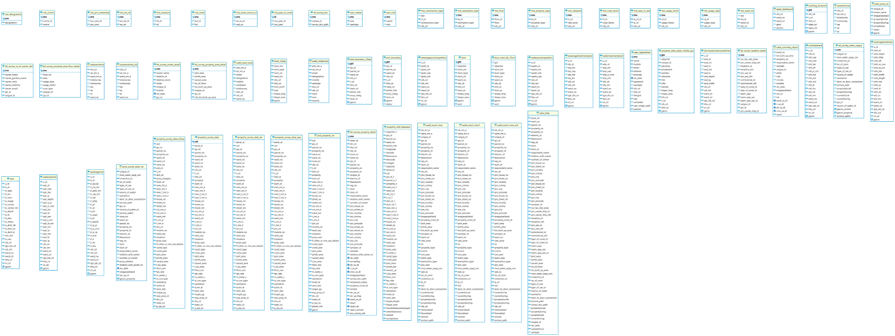

Action Template

Code Structure

DATA DESIGN

Database Architecture Diagram

The Jal Rekha System will implement data replication in a distributed environment to ensure high availability, scalability, and data security. Replication will improve system performance by maintaining multiple synchronized copies of the database across different servers.

The Master Database will handle both read and write operations.

Slave Databases will be used only for read operations to optimize performance and reduce the load on the master server.

In case of high traffic, read requests will be distributed among slave databases, ensuring faster response times.

The system will also maintain a Disaster Recovery (DR) Server where one of the slave databases will continuously synchronize data in real time. This ensures business continuity and prevents data loss in case of any server failure or unexpected downtime.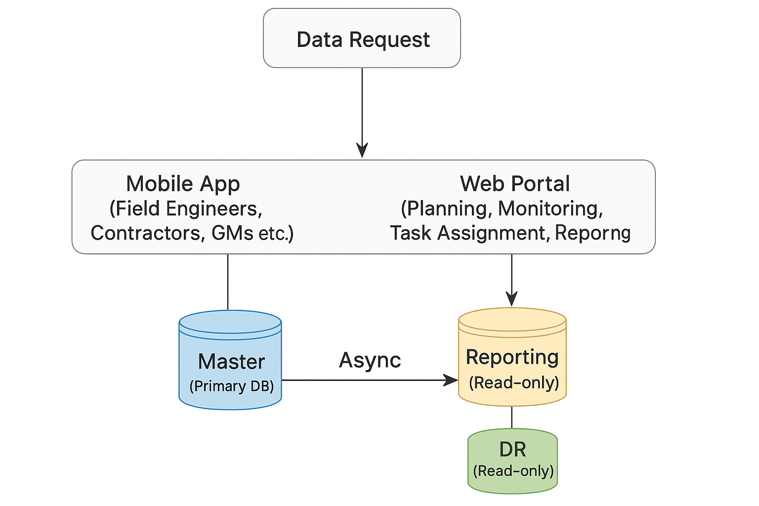

NETWORK DESIGN

Network Architecture Diagram

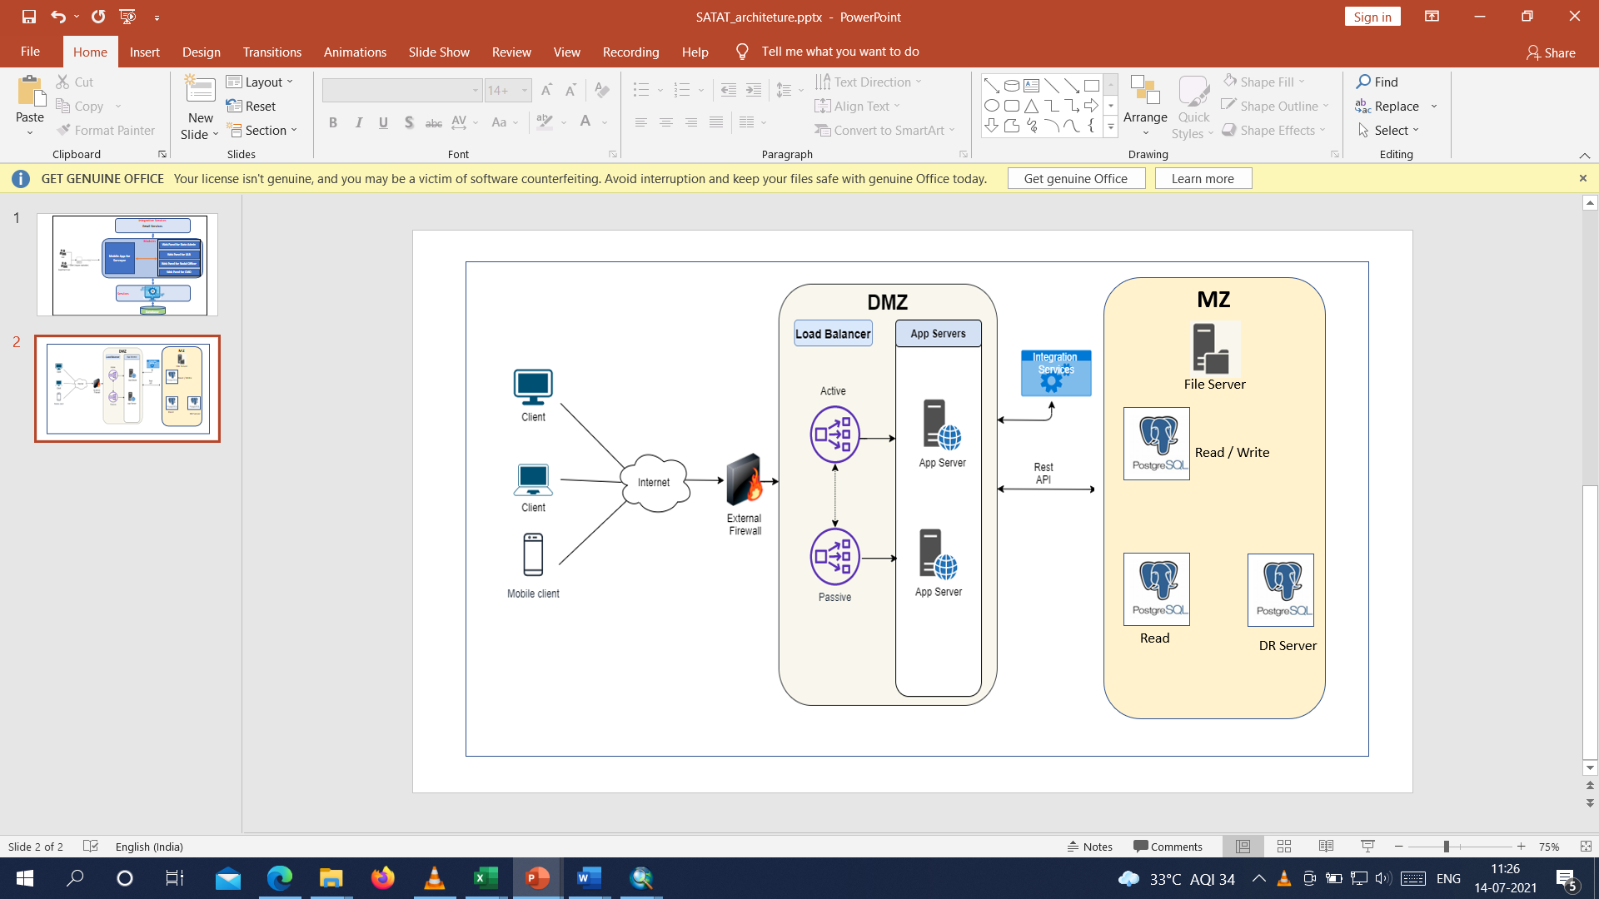

The Jal Rekha system has been designed with a highly secure, scalable, and fault-tolerant network architecture to ensure seamless service delivery for both web and mobile clients. The architecture consists of three major layers:

1. Client Layer
This layer represents all types of users accessing the Jal Rekha platform:
- Web Clients – Access the .NET-based portal for project management, monitoring, and reporting.
- Mobile Clients – Use the Android application for field updates, inspections, and data submissions.
- API Consumers – External systems or integration partners interacting through secure REST APIs.
All client requests are routed over HTTPS to ensure secure data transmission.

2. DMZ Layer (Demilitarized Zone)
The DMZ acts as a secure buffer zone between the external network and the internal system. It ensures that external users interact with application servers without exposing internal resources.

Key Components in DMZ:
- External Firewall
Protects the internal infrastructure by filtering unauthorized traffic and allowing only secure HTTPS requests.
- Load Balancer
  - Distributes client requests between multiple App Servers for better performance.
  - Supports Active-Passive Failover to ensure high availability.
- Application Servers (.NET-based)
  - Hosts the Jal Rekha web portal and REST APIs.
  - Manages business logic, API processing, and user authentication.
  - Handles Android and web requests in a unified way.
- Integration Services
  - Acts as a middleware layer for third-party systems such as GeoPortal, Payment Gateways, and SMS/Email services.
  - Communicates securely with the database layer via REST APIs.

3. MZ Layer (Main Zone / Data Layer)
This layer stores, processes, and manages Jal Rekha’s data.

Key Components:
- File Server
Stores uploaded documents, reports, images, and geospatial data securely.
- Master Database (PostgreSQL – Read/Write)
  - Centralized database for handling all read/write operations.
  - Stores service requests, project data, user information, and reports.
- Slave Database (PostgreSQL – Read-Only)
  - Optimized for reporting, dashboards, and analytics.
  - Offloads read-heavy queries from the master database to improve performance.
- Disaster Recovery (DR) Server
  - Maintains a real-time replicated copy of the master database.
  - Ensures data continuity in case of unexpected failures or downtime.

4. Security Features
- HTTPS Everywhere – All communications are encrypted using SSL/TLS.
- Role-Based Access Control (RBAC) – Ensures that users only access permitted data and services.
- Database Security – Uses real-time replication with secure authentication and encryption.
- API Security – All REST APIs require token-based authentication and are protected behind firewalls.

5. High Availability & Replication
- The Load Balancer ensures uninterrupted access even if one server goes down.
- Master-Slave Replication keeps a synchronized copy of data for reporting.
- The DR Server ensures zero data loss during system failures or natural disasters.
- The system can auto-promote a slave database as a master in case of hardware failure.

